5/5/2018

Be Well

Final Project Report

Adarsh Venkatesh Bodineni

SUID: 437100794

CIS-651 Mobile Application Programming

INSTRUCTOR – Dr. Mina Jung

Contents

1. Scroll View and Page Control 3

2. User Defaults Standard (Shared Preferences) 4

3. Finger Print Authentication 5

4. Camera and gallery 7

5. Table View Controller 9

6. Collection View 14

7. QR Code Scanning 16

8. Sharing 19

9. Maps 20

10. Youtube 22

11. Notifications 24

12. Host your data on Cloud 26

*12.1 Key-capabilities of Firebase:* 26

13. Security to Cloud Data 28

# Scroll View and Page Control

* The central notion of a UIScrollView object (or, simply, a scroll view) is that it is a view whose origin is adjustable over the content view.
* The application opens up with a combination of UIscroll view and page control.
* This view contains three pages each depicting the types of users uses this application.
* This view appears only one time when the user first uses the application, from next time this view won’t appear. This is achieved using the property user defaults(shared preferences).

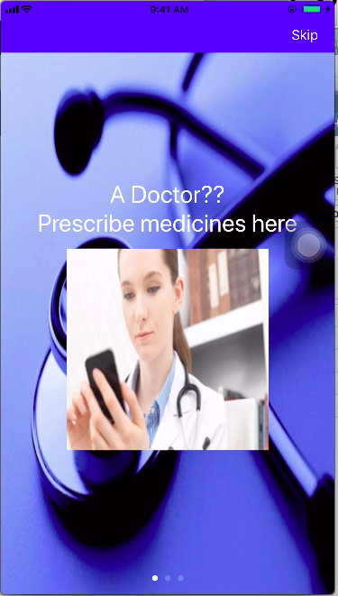

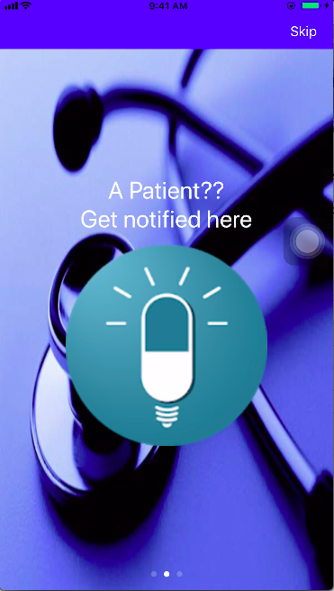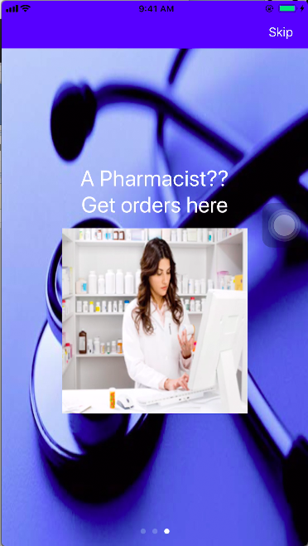

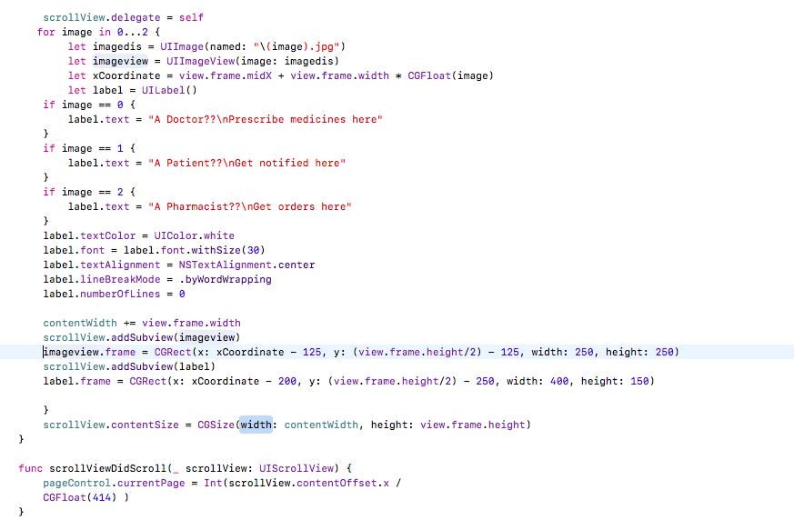

# User Defaults Standard (Shared Preferences)

* The User Defaults class provides a programmatic interface for interacting with the defaults system. The defaults system allows an app to customize its behavior to match a user’s preferences.
* Apps store these preferences by assigning values to a set of parameters in a user’s defaults database. The parameters are referred to as defaults because they’re commonly used to determine an app’s default state at startup or the way it acts by default.
* Using this user defaults preferences, the app is set to display the scroll view only once.

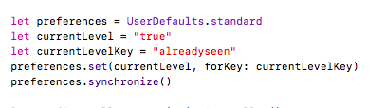

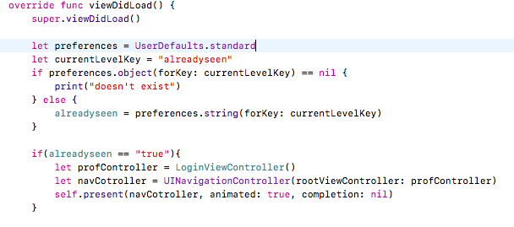

# Finger Print Authentication

* Finger print authentication uses Local Authentication framework that facilities for requesting authentication from users with specified security policies.
* An LAContext object represents an authentication context. The LAContext class provides a programmatic interface for evaluating authentication policies and access controls, managing credentials, and invalidating authentication contexts.

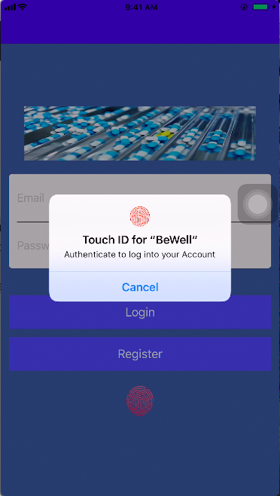

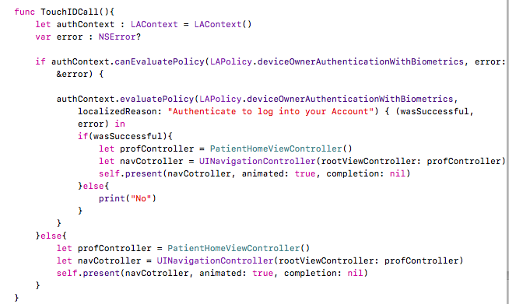

# Camera and gallery

* We have used camera and gallery to update profile picture of the user.
* The user on clicking the default image, he will get an option to select either “use camera” or “use gallery”.
* In “use camera” option, if the user is using the camera for first time, the application will ask for permissions to use the camera. Once he takes the picture, the picture will be stored in firebase database and loaded into the image view.
* In “use gallery” option, the user can choose the image from gallery and can upload it. The image will store in firebase and displayed on the image view.

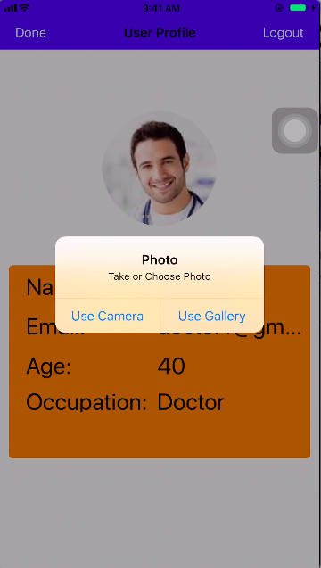

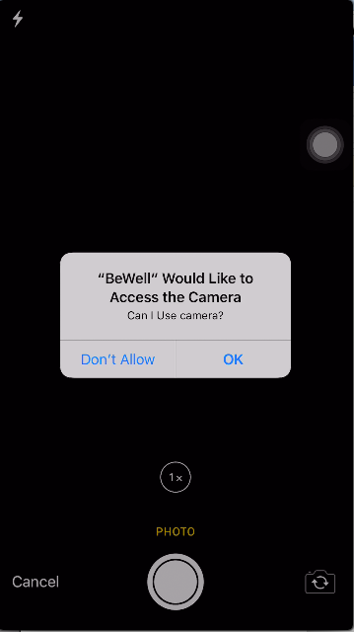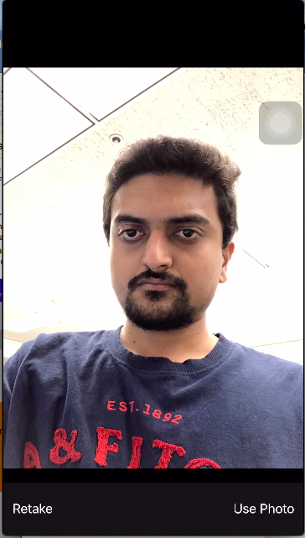

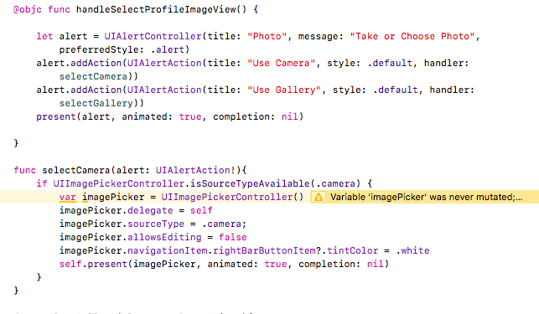

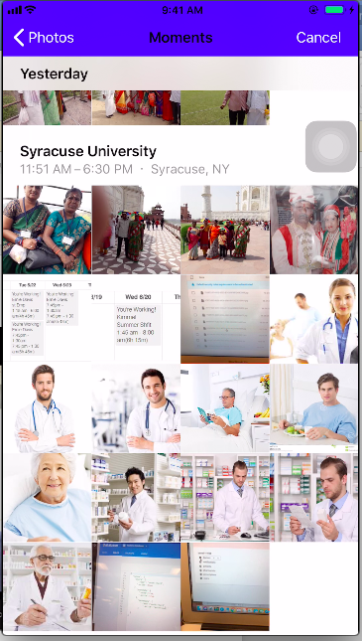

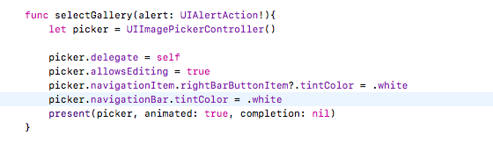

# Table View Controller

* UITable View controller is a view controller that specializes in managing a table view.
* When the table view is about to appear the first time it’s loaded, the table-view controller reloads the table view’s data. It also clears its selection (with or without animation, depending on the request) every time the table view is displayed.
* The table view is used in multiple places in this application.

* Doctor have a table view of his patients. The table view contains only the patients that are added by the doctor.
* 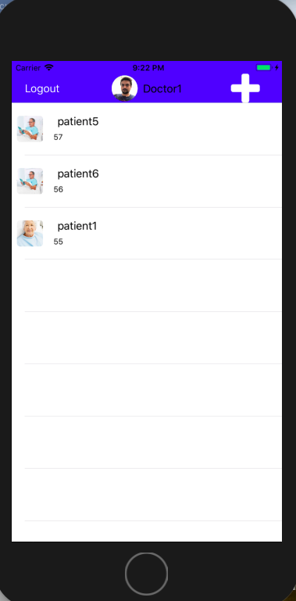
* Doctor can add patients to his list. On clicking on the plus button on the navigation bar, all the patients who are using this application are displayed in a table view. The doctor can add any one he wants.

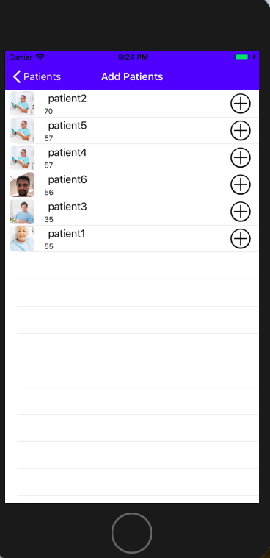

* The Doctor have patient detail screen where he can prescribe medicines to the patients, the list of prescriptions is formed into a table view.

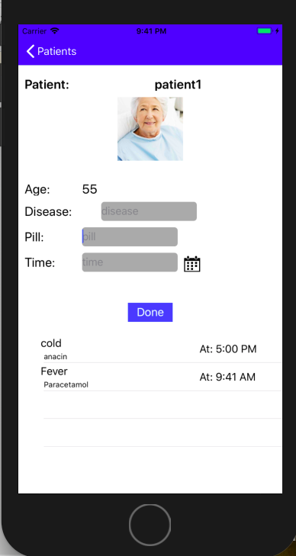

* The Patients have a table view where they can see their list of prescriptions given by doctor.

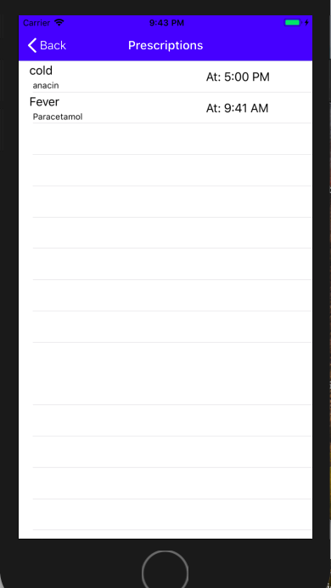

* The Patient also have a table view where he can check the status of orders he has done. Each cell of this table view has a checkbox that indicates whether the order is ready for pickup from the pharmacy shop.

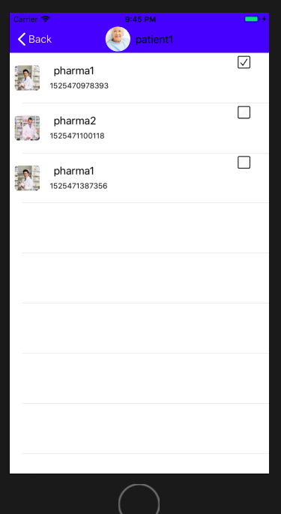

* The pharmacist has a table view that has list of orders he has received from different patients. He can differentiate the others by looking at the checkbox that he actually notified the patient that the medicines are packed and ready for pick up.

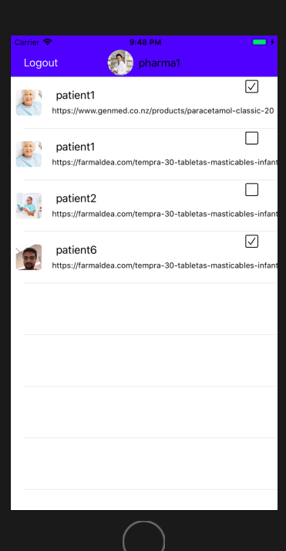

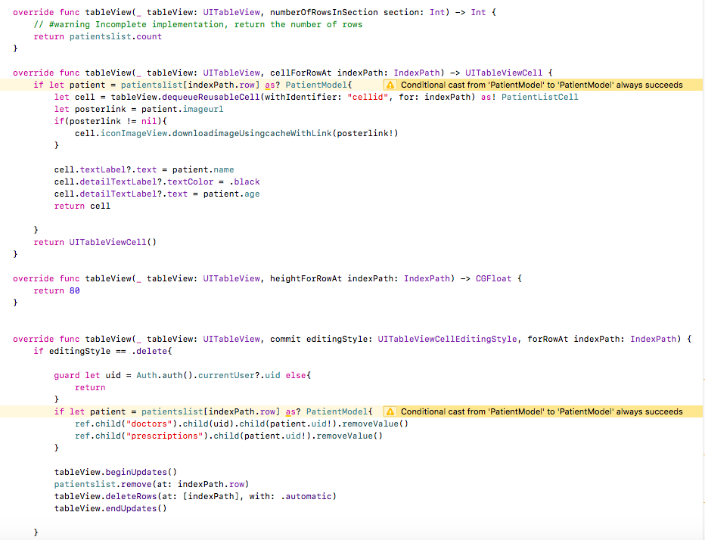

# Collection View

* The collection view gets its data from the data source object, which is an object that conforms to the [UICollectionViewDataSource](https://developer.apple.com/documentation/uikit/uicollectionviewdatasource) [Protocol](https://developer.apple.com/library/content/documentation/General/Conceptual/DevPedia-CocoaCore/Protocol.html#//apple_ref/doc/uid/TP40008195-CH45) and is provided by the app.
* Data in the collection view is organized into individual items, which can then be grouped into sections for presentation. An item is the smallest unit of data you want to present.
* The collection view is used in this application as a menu for patient. The patient is provided with two types of menu, one is the view controller itself that acts as collection view, and the other one is a pop up menu that will be added on clicking of a navigation item.

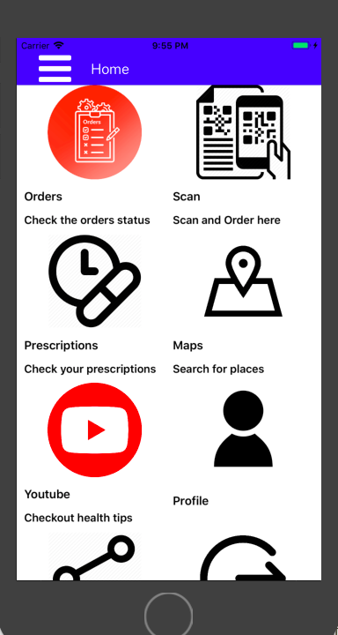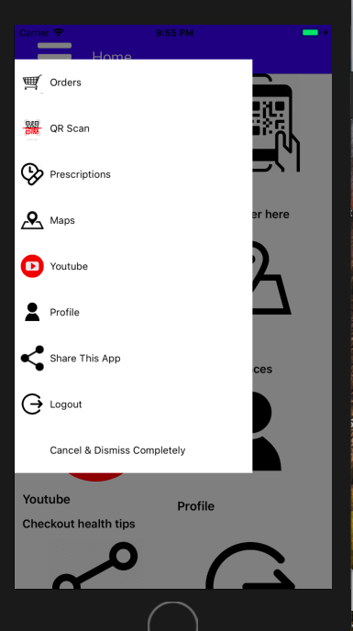

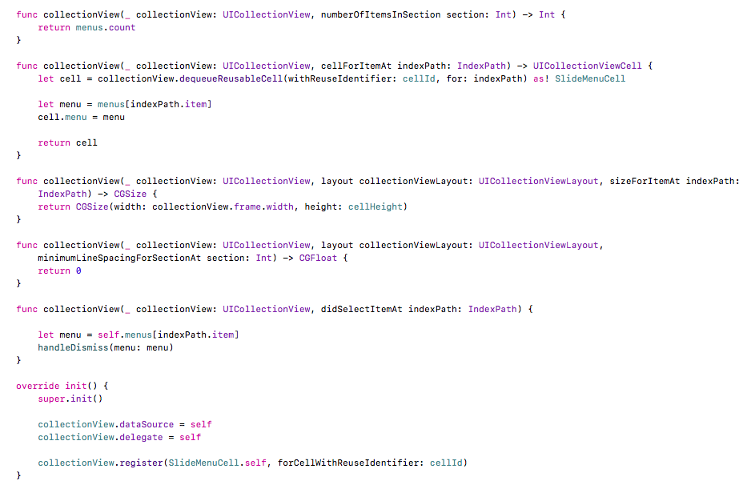

# QR Code Scanning

* The QR code scanner uses the AVFoundation framework to achieve this.
* It can scan the QR code of a label of medicine, hence helps to order things without specifying the medicine name.

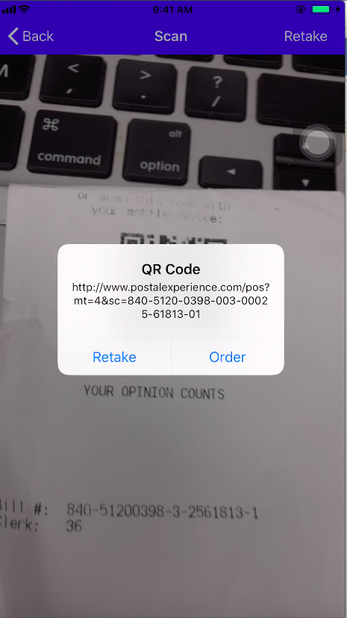

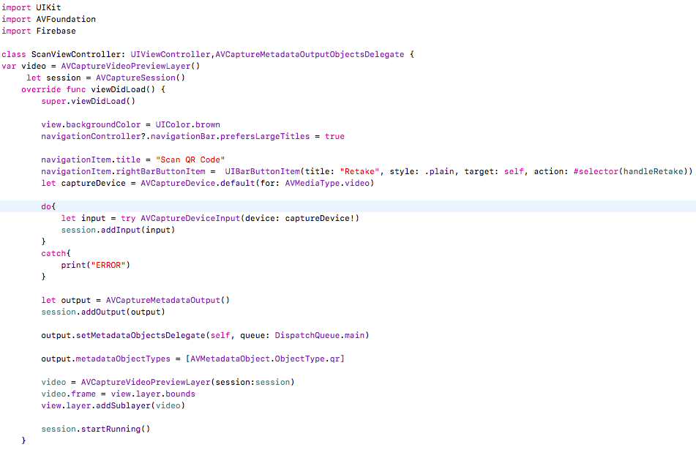  
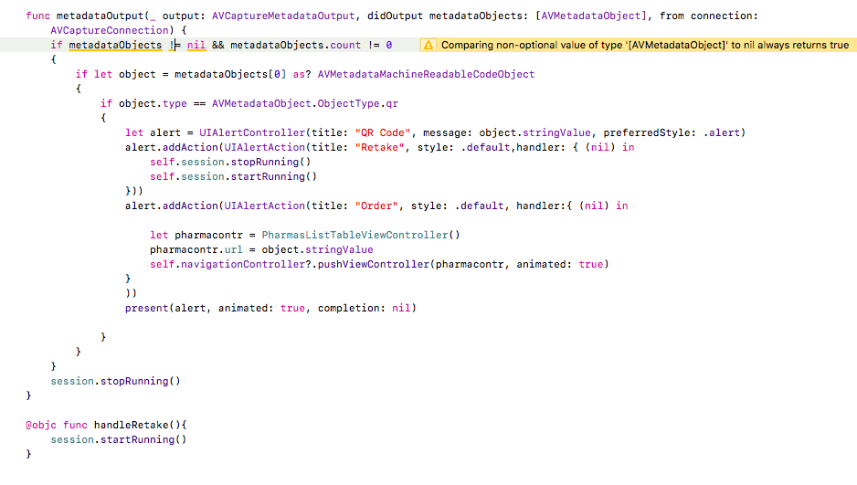

# Sharing

* UIActivityViewController provides several standard services, such as copying items to the pasteboard, posting content to social media sites, sending items via email or SMS, and more. Apps can also define custom services.

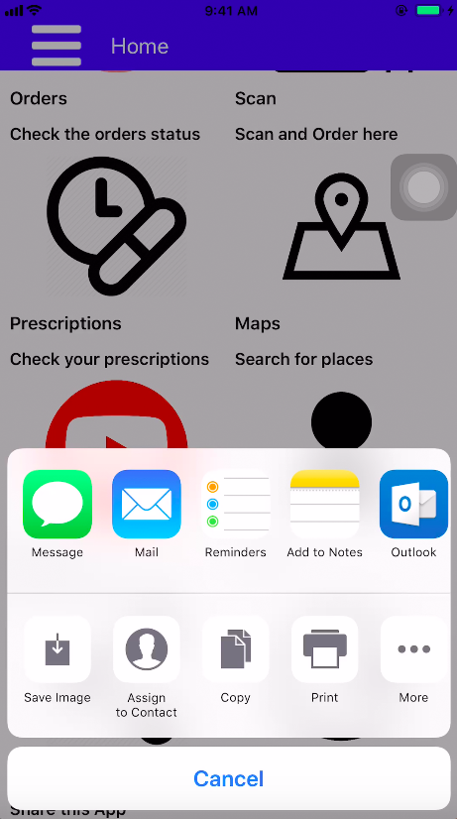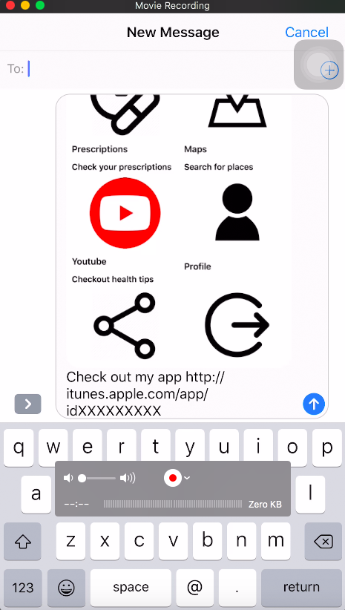

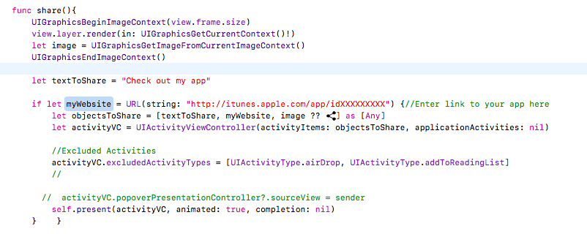

# Maps

* It uses Google Maps and Google Places.
* Google API is used to fetch data of places in ios.
* The main objective of this feature is it searches for the places the user types in.
* It contains a search bar that populates the table view based on the input the user gave. It shows all the closest matched places in that table view.
* The selected place is shown on the map with a marker and address on top of it.

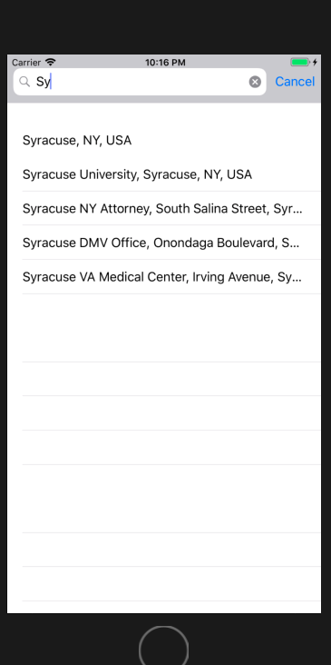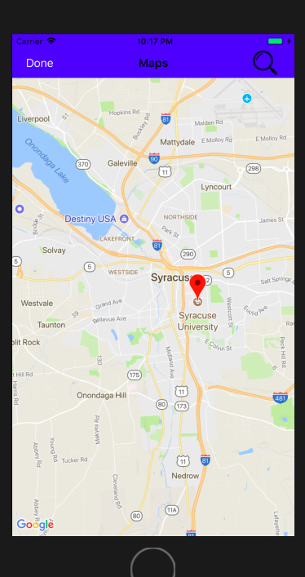

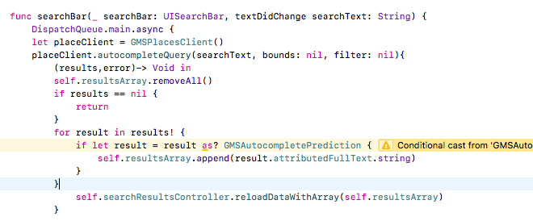

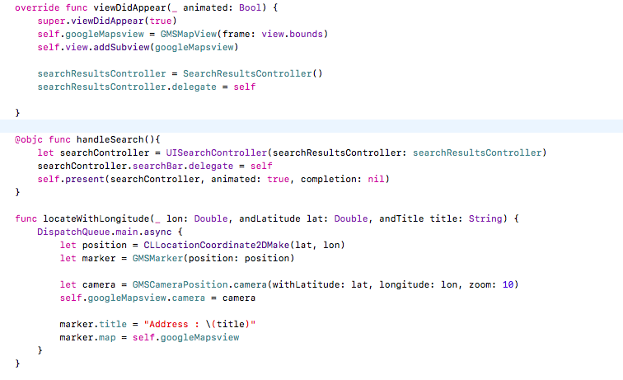

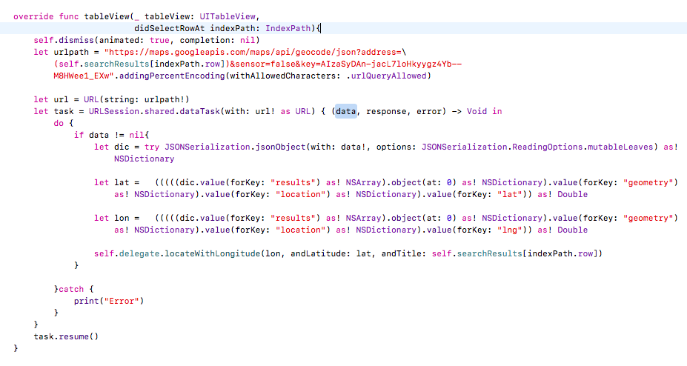

# Youtube

* Google API is used for to have access to YouTube videos in iOS.
* A playlist is added to a table view in the application and when the user clicks on the item of table view, the detail view shows up with a web view that plays the video.

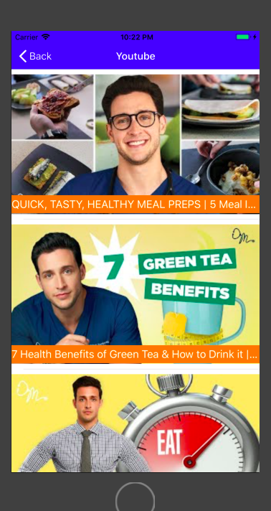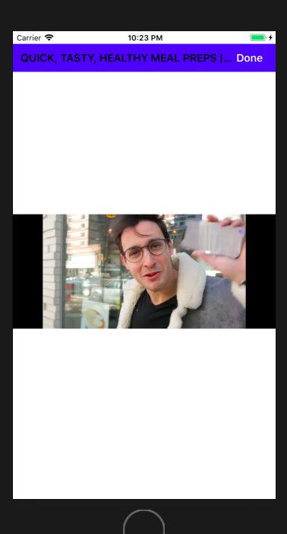

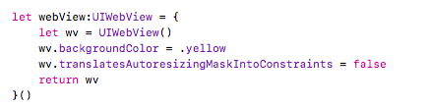

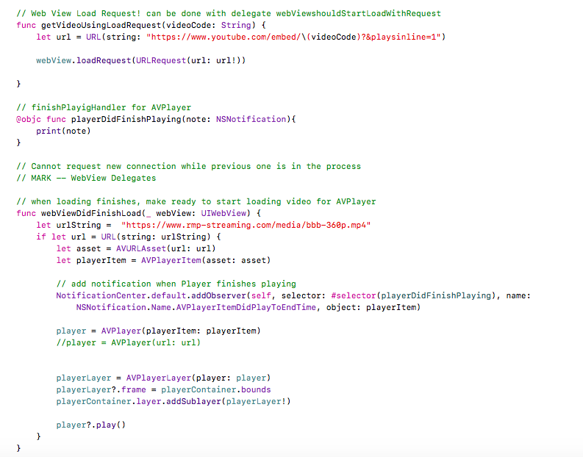

# Notifications

* The user notifications framework is used to achieve this.
* User-facing notifications communicate important information to users of your app, regardless of whether your app is running on the user's device.
* For **local notifications**, the app creates the notification content and specifies a condition, like a time or location, that triggers the delivery of the notification.
* In this application, the patient receives the notification to take pill at the time set by doctor.
* The patient also receives notification when the pharmacist sends that the order is ready for pick up.

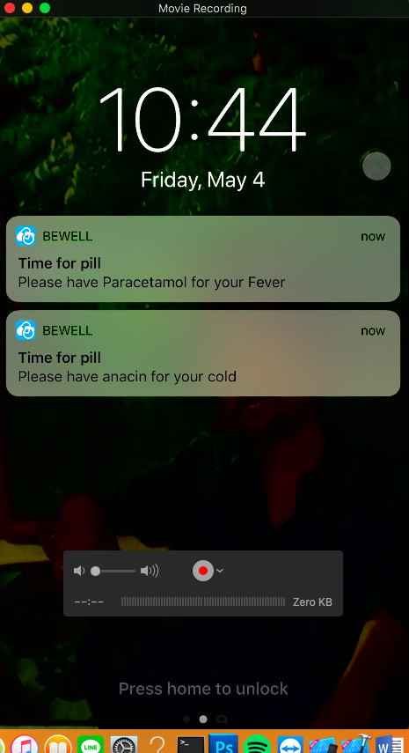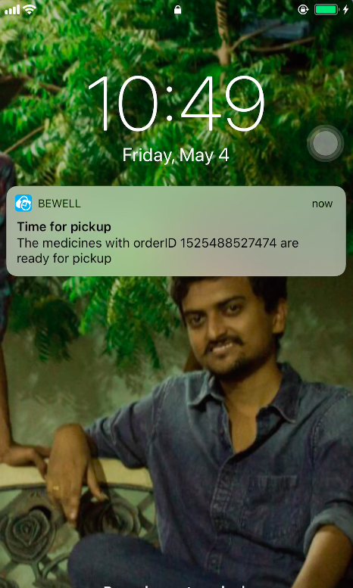

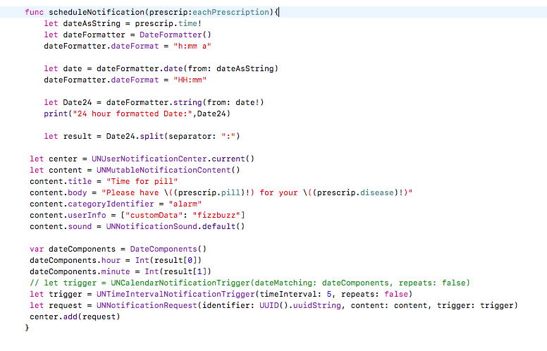

# 12. Host your data on Cloud

* Google provides powerful tool for cloud storage, NoSQL “key-value” based database and user authentication with security rules that helps developer to chase the functionalities of application quickly.
* In this app, we used cloud storage to store the profile picture of the user’s.
* Used **cloud database** to store the user details.
* The Firebase Real-time Database is a cloud-hosted database. Data is stored as JSON and synchronized in real-time to every connected client.
* **Authentication** feature provided by the Firebase with email-password and Gmail.

12.1 Key-capabilities of Firebase:

* Instead of typical HTTP requests, the Firebase Real-time Database uses data synchronization—every time data changes, any connected device receives that update within milliseconds.
* Firebase apps remain responsive even when offline because the Firebase Real-time Database SDK persists your data to disk. Once connectivity is reestablished, the client device receives any changes it missed, synchronizing it with the current server state.
* The Firebase Real-time Database can be accessed directly from a mobile device or web browser; there’s no need for an application server.**Security and data validation** are available through the Firebase Real-time Database Security Rules, expression-based rules that are executed when data is read or written.

Database:

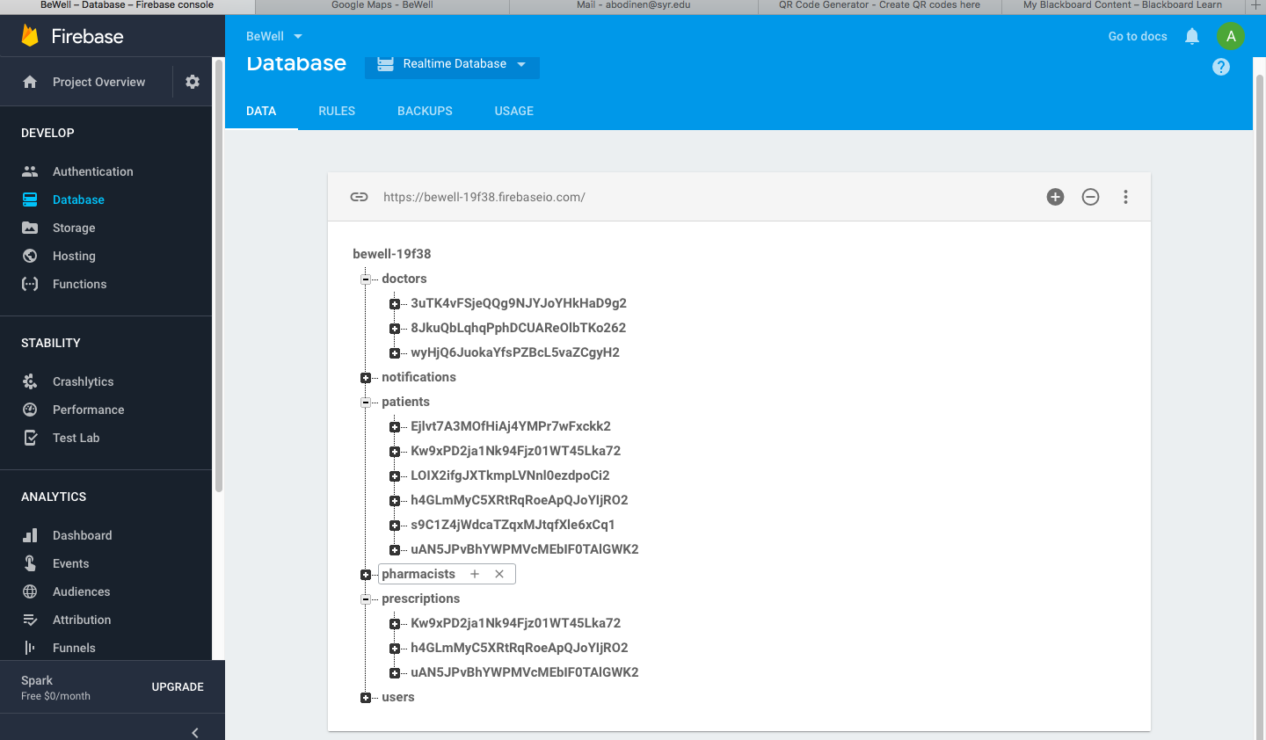

Storage:

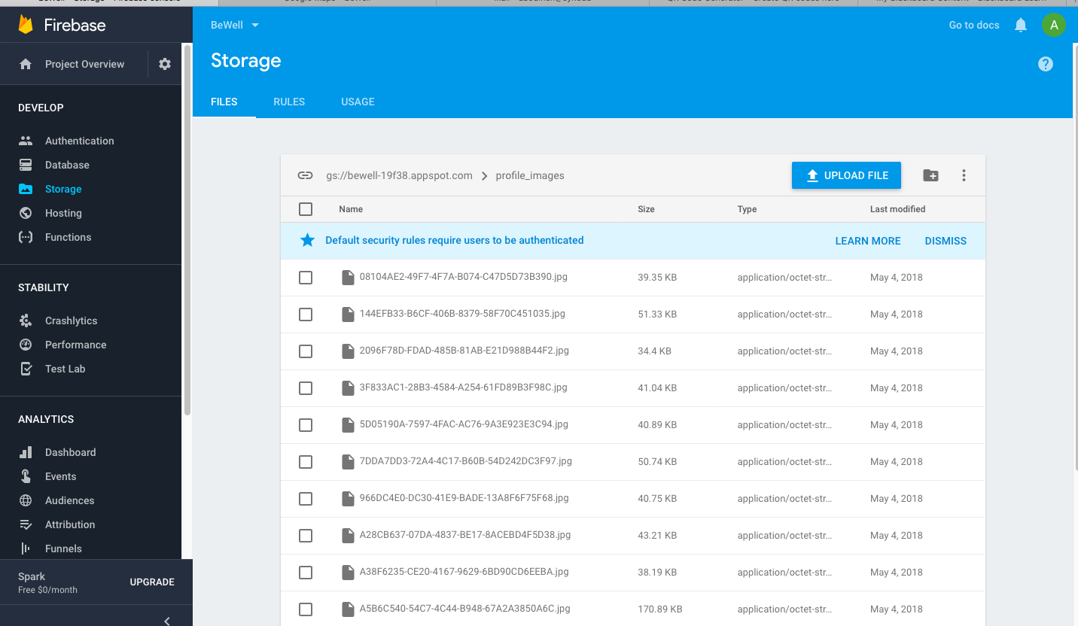

Authentication:

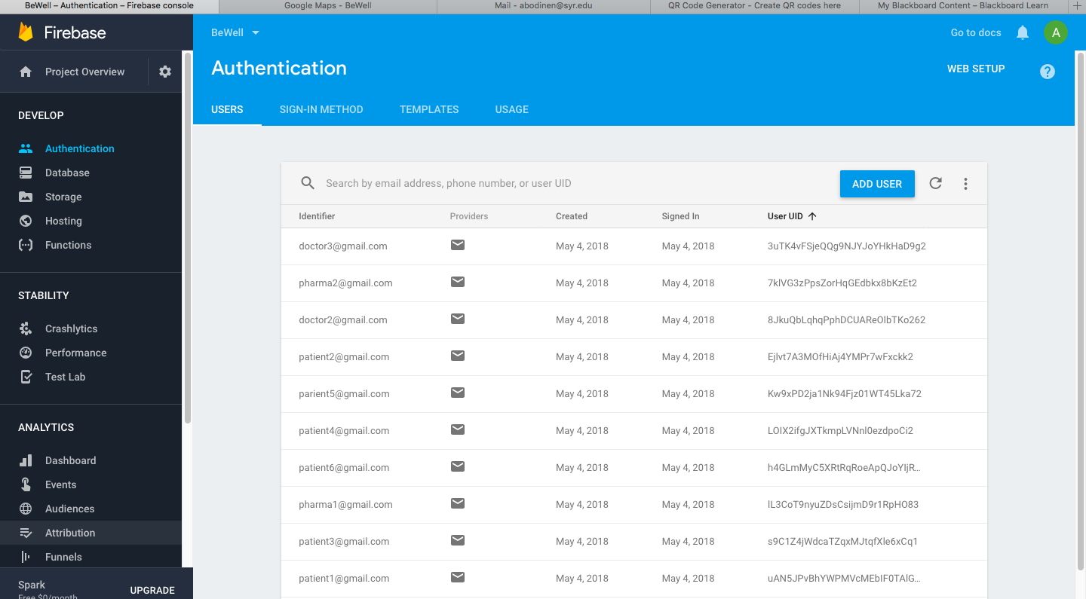

# Security to Cloud Data

* Used Firebase real time Database Security Rules to secure the data.

